User Interface Design and Database E-R Diagram

Glocal - Business Rating and Review System



Salman Azam Khan <salmanakhan@ufl.edu>

Chang Xu <theoneneo@ufl.edu>

Unmey Mahaddalkar <umahaddalkar@ufl.edu>

Shubham Agiwal <shubhamagiwal92@ufl.edu>

Table of Contents

1. Introduction……………………………………………………………………………… 2

2. User Interface Design………………………..….……………………………..…… 3

2.1 UI Pages......................................................................... 3

2.1.1 Login Page…………………………………………………………………… 3

2.1.2 Signup Page………………………………………………………………… 4

2.1.3 Forget Password Page…………………………………………………. 5

2.1.4 Confirmation Page…………………………………………….…………. 6

2.1.5 Home Page………………………………………………………….……….. 7

2.1.6 User Profile Page………………………………………………..………... 9

2.1.7 User Settings Page …………………………………………………….. 10

2.1.8 Search Page ………………………………………………………….……. 11

2.1.9 Business Page ………………………………………………….………... 12

2.1.10 Review Page ……………………………………………………..……… 14

2.1.11 Business Dashboard Page ………………………………………… 15

2.1.12 Business Settings Page …………………………………………….. 17

2.1.13 Business Analysis Page …………………………………………….. 18

2.2 UI Mockup Diagram……………………………………………………………… 19

3. Database ER Diagram…………………………………………………………………. 21

3.1 Entity Sets……………....………………………………………………………….. 22

3.2 Relationship Sets………...………………………………………………………..23

1. **Introduction**

The gist of our project is further elucidated in this document. After careful consideration of all design aspects, We settled on the flow of the web pages as described in sections 2 and 3.

A user will need to sign in or create an account before accessing the Glocal homepage. The Login page also contains a feature which sends an email to the specified email id if a user forgets the password used to create an account. The email will direct the user to the Settings page where the user can change their password. The user profile page will contain a list of all reviews written by them along with analytics such as average ratings for example. Business users get their own profile page with different tools to manage their businesses along with analytics directed to give information about the performance of businesses. Businesses also get a dedicated settings page. The homepage contains a search function with its own dedicated page along with top reviews and business information which leads to the respective pages. Furthermore categories are also mentioned and lead to the search page.

The Graphical interface for each page is minimally shown but enough to give an impression of what the final product entails and how all the features interact with each other. The User Interface design in section 2 details this aspect for every webpage with information about the page name, URL and a brief description along with how the webpage interacts with others. The UI Linkup diagram given in section 2.2 gives the overall overview of our conceptual design thus far.

The Entity - Relationship diagram is given in Section 3 and a detailed report of all entity sets and relationship sets follow in sections 3.1 and 3.2 respectively. We used the online tool draw.io to create the entity relationship diagram. We have used the cardinalities (1:m, m:1,m:n ) to represent the relationships between the entity sets. The ER diagram format is similar to what has been taught in class with green ellipses representing the attributes with key attributes underlined, red rectangles representing entity sets and blue rhombuses representing relationship sets. Dual lined shapes represent weak entities and respective relationships.

1. **User Interface Design**
   1. **UI Pages**
      1. **Login Page**

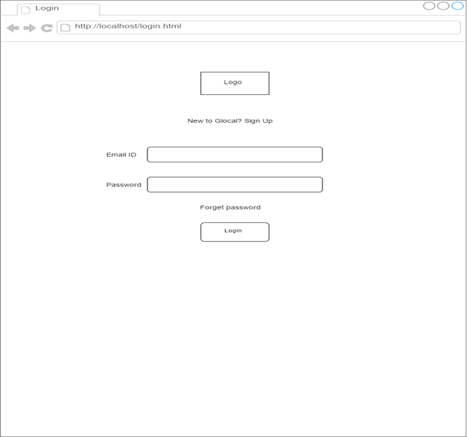**Page name:** Login Page

**URL:** <http://localhost/login.html>

**Description:** The login page consists of the Email address and password fields which will allow the user to enter the home page of the website.

**UI Linkup:**

1. Entering the correct email address and password allows the user to enter the home page (<http://localhost/homepage.html>).
2. If the user is new to this website, there exists a hyperlink to sign up (<http://localhost/signup.html>).
3. In case the user forgets his password, forget password link (<http://localhost/forgetpassword.html>) will direct the user to a new page.
   * 1. **Sign Up Page**

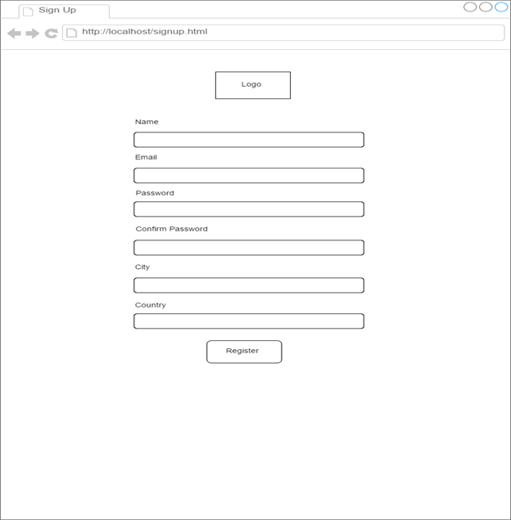

**Page name:** Sign up page

**URL:** <http://localhost/signup.html>

**Description:** The sign up page is the basic registration page for a new user which asks for personal information such as name, email address, password, confirm password, city and country.

**UI Linkup:**

Entering the required information and clicking on register redirects the user to the home page (<http://localhost/homepage.html>)

* + 1. **Forget Password Page**

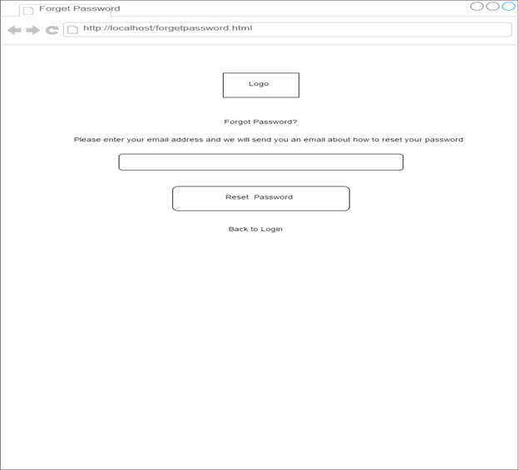

**Page name:** Forget password page

**URL:** <http://localhost/forgetpassword.html>

**Description:** The forget password page consists of the email address field and the reset password button button.

**UI Linkup:**

1. Clicking the reset password takes the user to the confirmation page: (<http://localhost/confirmationpage.html>).
2. In case the user accidentally entered this page, there exists a back to login page link (<http://localhost/login.html>).
   * 1. **Confirmation Page**

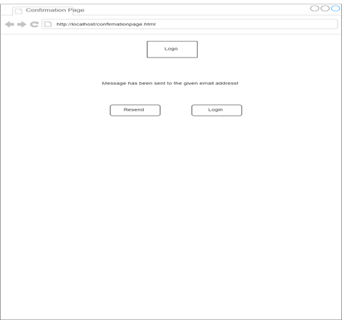

**Page name:** Confirmation page

**URL:** <http://localhost/confirmationpage.html>

**Description:** The confirmation page contains a text message which states that an email has been sent to the given email address. There is also an option to resend it or to login again after receiving a new password in the email.

**UI Linkup:**

1. Clicking on login button redirects the user to the login page (<http://localhost/login.html>).
2. Clicking on resend directs the user to the same page (<http://localhost/confirmationpage.html>).
   * 1. **Home Page**

search.png

**Page Name**: Home Page

**URL**: <http://localhost/homepage.html>

**Description:**

This page consists of the search function which allows users to navigate to the search page. A relevant picture will be present on the background to make the page look more pleasing. Furthermore, there will be information about the top reviews and businesses local to the users region which can allow quick access to what is popular around them. Selecting any of the features will lead to the relevant business/user profiles. User information is also provided in the top right corner of the page and leads to user settings or user profile pages.

A categories sub section at the bottom provides quick access to the search page along with the top businesses in the category chosen.

**UI Linkups:**

On the Web page, the logo provided will be not redirect to any url. The name displayed in the navigation bar will have a drop down option with the following options which upon a click will redirect the user to the corresponding pages mentioned below

1. About Me - <http://localhost/userProfile.html>
2. Settings - [http://localhost/userSettings.html](http://localhost/userProfile.html)
3. Logout- [http://localhost/login.html](http://localhost/userProfile.html)

The Search Bar on the page will enable the user to search businesses based on keywords entered. When the user types in a keyword and press enter key from the keyboard, the user will be redirected to the search page([http://localhost/search.html](http://localhost/userProfile.html)) and the search results will be based on the keyword entered. The Home Page also has Top Reviews given by the users using the glocal platform. On clicking the reviews, the user will be redirected the business page([http://localhost/businessPage.html](http://localhost/userProfile.html)) which which details of the corresponding business with the latest reviews the business received. The homepage also consists of the Top Business based on a business logic which keeps changing based from time to time. On clicking on any of the business, the user will be redirected the business page([http://localhost/businessPage.html](http://localhost/userProfile.html)) which which details of the corresponding business with the latest reviews the business received. The Home Page also contains the search based on categories such as restaurants, shopping etc. Based on the selection of the categories, the user will be redirected to the search page([http://localhost/search.html](http://localhost/userProfile.html)) with the appropriate results based on the category selection.

* + 1. **User Profile Page**

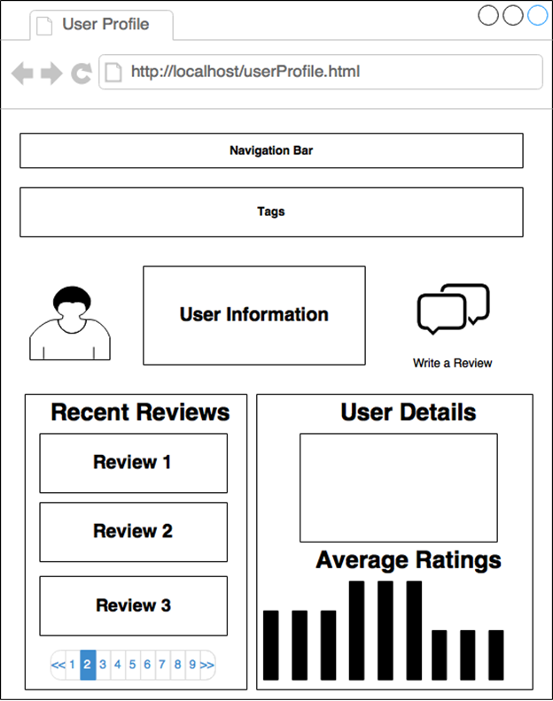

**Page name:** User Profile page

**URL:** <http://localhost/userProfile.html>

**Description:** The user profile page consists of information regarding the users and their interactions and history with glocal. This page provides user details such as their name, address, city, state along with their recent reviews for businesses all ordered according to dates posted. Also included in this page will be the average ratings made by the user as well as some analytics specific to users and their experience with glocal.

**UI Linkup:**

1. Clicking on navigation bar or tags redirects the user to the search page (<http://localhost/search.html>).
2. Clicking on any of the reviews redirects the user to the business page (<http://localhost/businessPage.html>).
   * 1. **User Settings Page**

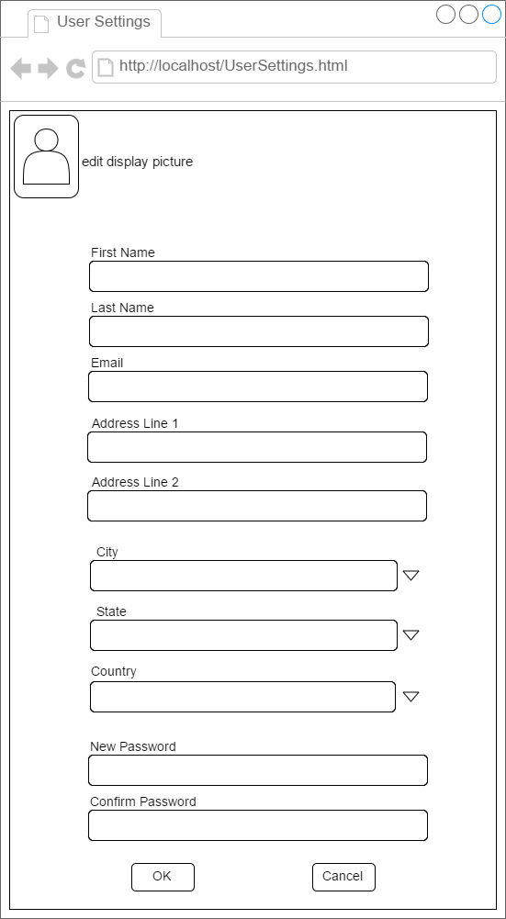

**Page name:** User Settings page

**URL:** <http://localhost/userSettings.html>

**Description:** The settings page allows a user to update information about themselves and contains entries that are used in other pages to refer to users. This is a simple page which also allows a user to update their password when they wish to change it.

**UI Linkup**

1. Clicking on ‘OK’ directs the user to the same page with updated information (<http://localhost/userSettings.html>).
2. Clicking on ‘Cancel’ directs the user to the same page with the previous information (<http://localhost/userSettings.html>).

* + 1. **Search Page**

search.png

**Page Name**: Search Page

**URL**: [http://localhost/search.html](http://localhost/homepage.html)

**Description:**

This Page consists of search function which allows the user to get results based on the keyword search, quick search and category based search on businesses. It consists of the navigation bar which consists of the quick and keyword search. So based on the parameters passed, this page will display top ten businesses with pagination. The top characteristic will be based on a business logic which is yet to be decided on. User information is also provided in the top right corner of the page and leads to user settings or user profile pages.

**UI Linkups:**

The Navigation bar along with the tag will enable the user to search businesses based on parameters such as keyword, tags etc. Upon click or press of enter on the keyboard, the user will be redirected to the search page([http://localhost/search.html](http://localhost/userProfile.html)) displaying the results based on the parameters passed. The name displayed in the navigation bar will have a drop down option with the following options which upon a click will redirect the user to the corresponding pages mentioned below

1. About Me - <http://localhost/userProfile.html>
2. Settings - [http://localhost/userSettings.html](http://localhost/userProfile.html)
3. Logout- [http://localhost/login.html](http://localhost/userProfile.html)

The page will consists of the top businesses based on the parameters passed by the user. It will have a pagination option at the bottom of the page to view businesses based on the business logic. The businesses provided on the webpage will be redirected to the corresponding business Page([http://localhost/businessPage.html](http://localhost/userProfile.html)) which which details of the corresponding business with the latest reviews the business received.

* + 1. **Business Page**

businessPage.png

**Page Name**: Business Page

**URL**: [http://localhost/businessPage.html](http://localhost/homepage.html)

**Description:**

This Page consists of search function which allows the user to get results based on the keyword search, quick search and category based search on business. It consists of the navigation bar which consists of the quick and keyword search.The top characteristic will be based on a business logic which is yet to be decided on. User information is also provided in the top right corner of the page and leads to user settings or user profile pages. The page mainly describes the business details and the latest reviews it received from the users in the platform.

**UI Linkups:**

The Navigation bar along with the tag will enable the user to search businesses based on parameters such as keyword, tags etc. Upon click or press of enter on the keyboard, the user will be redirected to the search page([http://localhost/search.html](http://localhost/userProfile.html)) displaying the results based on the parameters passed. The name displayed in the navigation bar will have a drop down option with the following options which upon a click will redirect the user to the corresponding pages mentioned below

1. About Me - <http://localhost/userProfile.html>
2. Settings - [http://localhost/userSettings.html](http://localhost/userProfile.html)
3. Logout- [http://localhost/login.html](http://localhost/userProfile.html)

This page will contain business details such as it start time of the business everyday and other parameters and reviews it has received from various users on the platform. If the user wants to give a review to the business, he/she can click on the write a review which will redirect the user write Review Page([http://localhost/writeReview.html](http://localhost/userProfile.html)). The user can find out the details of the other users by clicking on the user details provided along the reviews on the business page. On click, the user will redirected to the user details page of the user(<http://localhost/userProfile.html>). Also this page will consists certain analytics on the business such as the rating distribution etc. Also the reviews provided by the users for the business will have a pagination option.

* + 1. **Review Page**

review.png

**Page Name**:Review Page

**URL**: [http://localhost/writeReview.html](http://localhost/homepage.html)

**Description:**

This Page consists of search function which allows the user to get results based on the keyword search, quick search and category based search on business. It consists of the navigation bar which consists of the quick and keyword search.The top characteristic will be based on a business logic which is yet to be decided on. User information is also provided in the top right corner of the page and leads to user settings or user profile pages. The main crux of the page is to enable the user to write review and provide ratings for a given business.

**UI Linkups:**

The Navigation bar along with the tag will enable the user to search businesses based on parameters such as keyword, tags etc. Upon click or press of enter on the keyboard, the user will be redirected to the search page([http://localhost/search.html](http://localhost/userProfile.html)) displaying the results based on the parameters passed. The name displayed in the navigation bar will have a drop down option with the following options which upon a click will redirect the user to the corresponding pages mentioned below

1. About Me - <http://localhost/userProfile.html>
2. Settings - [http://localhost/userSettings.html](http://localhost/userProfile.html)
3. Logout- [http://localhost/login.html](http://localhost/userProfile.html)

The page will contain the basic business details to whom you are giving a review to. The user can provide the ratings and the review to the given business. On confirmation of the review being added on the platform, the user will be redirected to the business page([http://localhost/businessPage.html](http://localhost/homepage.html)) where he/she can view his review. If the user click on the cancel button which giving the review, the user will be redirected to the business page([http://localhost/businessPage.html](http://localhost/homepage.html)).

* + 1. **Business Dashboard Page**

businessDashboard.png

**Page Name**:Business Dashboard

**URL**: [http://localhost/businessDashboard.html](http://localhost/homepage.html)

**Description:**

This Page consists of search function which allows the business user to get results based on the keyword search, quick search and category based search on business. It consists of the navigation bar which consists of the quick and keyword search.The top characteristic will be based on a business logic which is yet to be decided on. User information is also provided in the top right corner of the page and leads to user settings or user profile pages. Business Dashboard Page provides a list view of Businesses for Business Owners. It contains links to add new Business (Add button), edit existing Business (Edit button) and see Business Analysis (by clicking Business Name). Only Business Owner can be navigated to the Business Dashboard Page; Customers are not eligible to see this page.

**UI Linkups:**

The Navigation bar along with the tag will enable the user to search businesses based on parameters such as keyword, tags etc. Upon click or press of enter on the keyboard, the user will be redirected to the search page([http://localhost/search.html](http://localhost/userProfile.html)) displaying the results based on the parameters passed. The name displayed in the navigation bar will have a drop down option with the following options which upon a click will redirect the user to the corresponding pages mentioned below

1. About Me - <http://localhost/userProfile.html>
2. Settings - [http://localhost/userSettings.html](http://localhost/userProfile.html)
3. Logout- [http://localhost/login.html](http://localhost/userProfile.html)

This page will provide the business dashboard for the business owner. The business owner can add a new business by clicking on the add option on the page which will redirect him to business settings page([http://localhost/businessSettings.html](http://localhost/BusinessSettings.html)) where he can enter the corresponding details. The business owner can also edit details of the given business on the dashboard by clicking on the corresponding business edit option which will redirect the business owner to the business settings page([http://localhost/businessSettings.html](http://localhost/BusinessSettings.html)) for the corresponding business. When the business owner clicks on the business name, he/she will be redirected to the business analytics page([http://localhost/businessAnalysis.html](http://localhost/BusinessSettings.html)).

* + 1. **Business Settings Page**

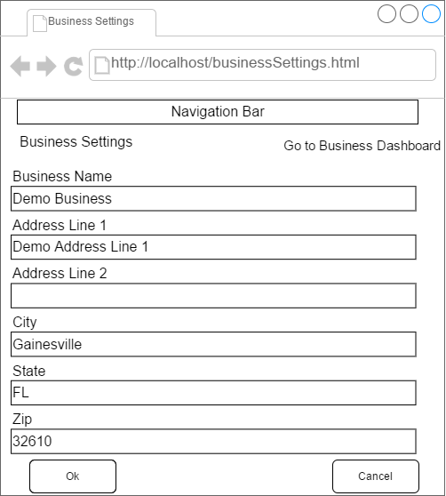

**Page name:** Business Settings page

**URL:** [http://localhost/businessSettings.html](http://localhost/BusinessSettings.html)

**Description:** Business Settings Page provides the ability to modify Business attributes. Editable attributes include basic Business information, Business Hours, Business Tags, and Business Image.

**UI Linkup:**

1. The navigation bar redirects the user to the search page of different businesses.(<http://localhost/search.html>)
2. Clicking on ‘OK’ redirects the user to the business dashboard page with the updated information (<http://localhost/businessDashboard.html>).
3. Clicking on ‘Cancel’ redirects the user to the business dashboard page with the previously existing information (<http://localhost/businessDashboard.html>).
   * 1. **Business Analysis Page**

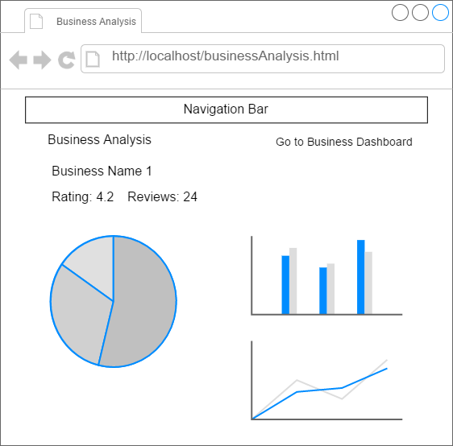

**Page name:** Business Analysis Page

**URL:** <http://localhost/businessAnalysis.html>

**Description:** This page provides Business Statistics for the Business Owners. The analysis will be generated based on Reviews, User Activities, etc. In the early release, following analysis will be provided:

1. Number of reviews received by the given business.
2. Number of unique users logging and giving reviews for a given business.
3. Total number of reviews per month for a given year.
4. Number of days since the last review for the business for a given date.
5. Rating distribution based on reviews in pie chart format.
6. Number of days between first and last review.

**UI Linkup:**

1. The analysis page allows an option to go back to the business dashboard (<http://localhost/businessDashboard.html>).
2. The navigation bar redirects the user to the search page of different businesses.(<http://localhost/search.html>).
   1. **UI mockup diagram**

The UI Mockup Diagram with all the screens and its various linkages is provided below.

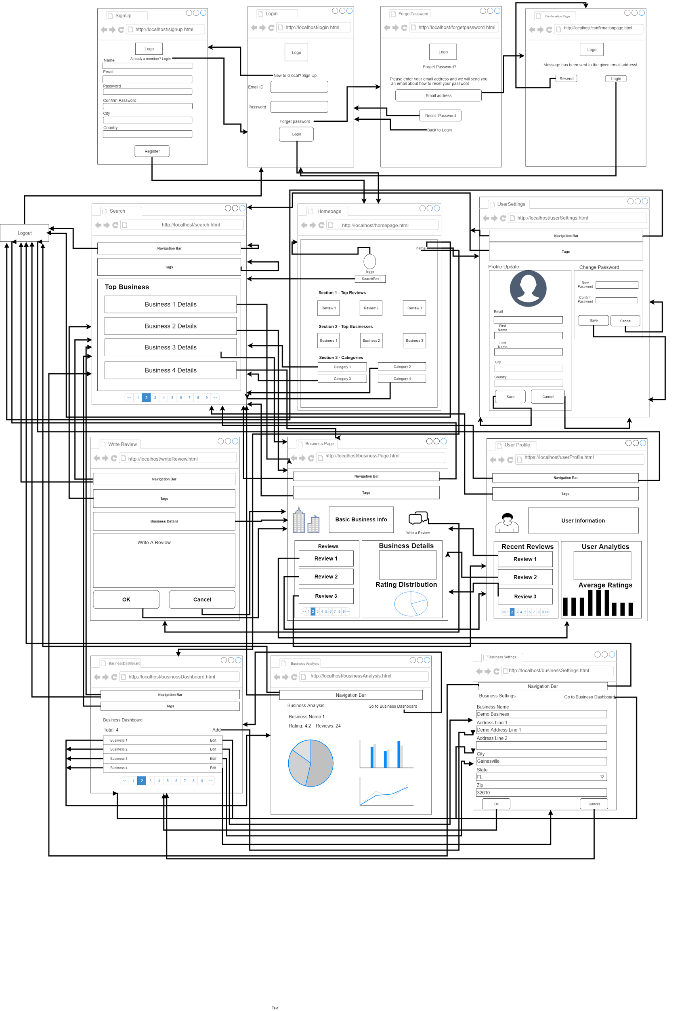

1. **Database E-R Diagram**

ER Diagram.png

* 1. **Entity Sets**
     1. **User**

User Set contains basic attributes of Users (both Customers and Business Owners). These attributes can be shown on the User Profile Page and can be edited on User Settings Page. User_ID is the primary key; Email must be unique.

* + 1. **User Credential**

User Credential Set contains hashed passwords of Users with the salts used in hashing process. It’s security consideration to separate the storage of User basic information and password into different sets.

* + 1. **User Access Token**

User Access Token Set contains login authentication tokens of Users. One User can have multiple effective tokens.

* + 1. **User Type**

User Type Set contains definitions of available User types. For current release, there are only two types: Customer and Business Owner.

* + 1. **Business**

Business Set contains basic attributes of Businesses. These attributes can be shown on the Business Page and can be edited by Business Owners on the Business Settings Page. Business_ID is the primary key.

* + 1. **Business Hour**

Business Hour Set contains hours settings of all Businesses. These attributes can be shown on the Business Page and can be edited by Business Owners on the Business Settings Page. A Business can have multiple records of Business Hour for different weekdays. Hour_ID is the primary key..

* + 1. **Tag**

Tag Set contains definitions of all Business Tags. It belongs to the system level configuration. At this phase, we use a flat, simplified Tag system to label Businesses. Tag_ID is the primary key.

* + 1. **Review**

Review Set contains basic attributes of Business Reviews. These attributes can be shown on the Business Page; they can be edited by Customers on the Review Page when writing new Reviews. Review_ID is the primary key.

* + 1. **Image**

Image Set contains basic attributes of Images uploaded by Users. Image files will be stored externally and only the URLs are stored in this Set. The attributes in Image Set will be used when front-end displays Images. Image_ID is the primary key.

* + 1. **Weekday**

Weekday Set contains definitions of the seven weekdays.

* 1. **Relationship Sets**
     1. **Uses**

Uses Set connects User Set with User Credential Set by User_ID. It establishes a 1:1 relationship between the two entity sets.

* + 1. **Accesses**

Accesses Set connects User Set with User Access Token Set by Token_ID and User_ID. It establishes a 1:m relationship between the two entity sets.

* + 1. **Holds**

Holds Set connects User Set with User Type Set by User_Type_ID and User_ID. It establishes a 1:m relationship between the two entity sets.

* + 1. **Writes**

Writes Set connects Review Set with User Set and Business Set by Review_ID, User_ID and Business_ID. One Review must be related to exactly one User and one Business; one User can write multiple Reviews to the same or different Business; one Business can have multiple Reviews. Only Customers can write Reviews; Business Owners are not allowed to do that.

* + 1. **Likes**

Likes Set connects Review Set with User Set by Review_ID and User_ID. It establishes a m:n relationship between the two entity sets. User can like a specific Review at most once. Only Customers can like Reviews; Business Owners are not allowed to do that.

* + 1. **Owns**

Owns Set connects Business Set with User Set by Business_ID and User_ID. One Business Owner can own multiple Businesses; one Business can be owned by only one Business Owner. Customers are not allowed to own Business.

* + 1. **Works**

Works Set connects Business Set with Business Hour Set by Business_ID and Hour_ID. It establishes a 1:m relationship between the two entity sets.

* + 1. **Matches**

Matches Set connects Business Hour Set with Weekday Set by Hour_ID and Weekday_ID. It establishes a 1:m relationship between the two entity sets.

* + 1. **Has**

Has Set connects Business Set with Tag Set by Business_ID and Tag_ID. It establishes a m:n relationship between the two entity sets.

* + 1. **User Image Uploads**

User Image Uploads Set connects Image Set with User Set by Image_ID and User_ID. It establishes a 1:m relationship between the two entity sets.

* + 1. **Business Image Uploads**

Business Image Uploads Set connects Image Set with Business Set by Image_ID and Business_ID. It establishes a 1:m relationship between the two entity sets.